*Rahul Aggarwal (190103120)*

*Dheeraj Nahar (190103035)*

**6-R MANIPULATOR MILLING AND   
GRINDING MACHINE**

**AIM**

Designing of an 6-R Manipulator for milling and grinding Process followed by its formation in CAD ,path planning for a Simple 2-D work and Simulation of it and Working in Powermill.

**Software Used**

* **Solidworks**

For the design purpose of robotic arm

* **Inkscape**

For the image processing of the design

* **Autodesk PowerShape and Powermill**

For the Path planning , simulation of the arm and product design

**FEATURE OF ROBOTIC ARM :-**

* Articulated
* Six degrees of freedom
* Six axes of Rotation
* Automatic
* High Precision

**Orientation of Metal Sheet :-**

* Perpendicular to the drill
* Dimensions according to the reach of the arm
* Thickness should not be more than the length of the drill

**Procedure**

* We have drawn the following parts in solid works for its construction- Base Shoulder, elbow,wrist and drill/gripper.
* Further we will be using servo motors and gears for its rotation.
* Creating an animated video for Assembly and Rotation of Axis
* Conversion of Cad file into URDF file.
* Using Autodesk powermill for the configuration and provide high preference to drill then other parts.
* Extraction of CL points of the metal via Image Processing using Inkscape which converts images into a .dxf file which we can access in Autodesk powershape for further processing.Further we can convert from Powershape to Powermill to get the path file.
* In the Autodesk we need to do all the similar steps such that connect all the single curves and get path curves to get the CL data of the points on which we want to move our robot. In this the joint angle for the consecutive points is such that the change in joint angle is minimum. This means we need to optimize the joint angle of the points.
* Now, we need to connect the curves on which our drill will work together if we have more than one unconnected curve, Then we need to set the initial points of the drill and then we will trace the path on the metal sheet such that we get the design of our choice.

**Advantages**

* Drilling and cutting using an automated robotic arm is better than manual because in this we need to provide the CL data and then the machine converts it into Joints angles for all the points and then optimize it such that the angles between two consecutive points on a single curve which give more accuracy and better result.
* This 6R manipulator provides more flexibility than any other machine as it has 6 axes of rotation also it can mill a complex part from multiple angles.
* Affordability - Milling with a robotic arm is extremely economical. Unlike milling machines, robots can be reassigned to perform other assignments in a shop - arc welding, material handling,3D printing, painting and many more . They can improve throughput, saving valuable time and increasing production. In addition, a robotic arm can handle more of the milling task without needing human intervention.
* With the inclusion of AI and ML algorithm’s it can be fully automated and provide more function and flexibility and be unbounded by human errors.

We can also get 3d design by doing some changes in our model. This robot has many industrial advantages such that it can reduce manpower and produce more precise and better products.

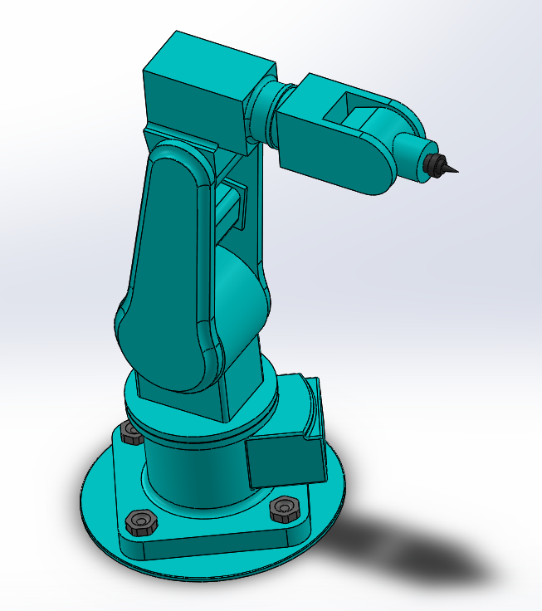

Final design of the Arm